Addressing table
Interface | Host Address | Subnet Mask | Default Gateway | Network Address
Distribution Router 1 (CSE)
GE0/2 | 10.28.88.2/29 | 255.255.255.248 |  | 10.28.88.0/29
GE2/0.10 =student | 10.28.32.1/21 | 255.255.248.0 | 2048 | 10.28.32.0/21
GE2/0.20 | 10.28.64.1/22 | 255.255.252.0 |  | 10.28.64.0/22
GE2/0.30 | 10.28.80.1/23 | 255.255.254.0 |  | 10.28.80.0/23
Distribution Router 2 (BBA)
SF1 | 10.28.88.10/29 | 255.255.255.248 |  | 10.28.88.8/29
GE2/0.10 | 10.28.40.1/21 | 255.255.248.0 |  | 10.28.40.0/21
GE2/0.20 | 10.28.68.1/22 | 255.255.252.0 |  | 10.28.68.0/22
GE2/0.30 | 10.28.82.1/23 | 255.255.254.0 |  | 10.28.82.0/23
Distribution Router 3 (NFS)
SFP1 | 10.28.88.18/29 | 255.255.255.248 |  | 10.28.88.16/29
GE2/0.10 | 10.28.48.1/21 | 255.255.248.0 |  | 10.28.48.0/
GE2/0.20 | 10.28.72.1/22 | 255.255.252.0 |  | 10.28.72.0/22
GE2/0.30 | 10.28.84.1/23 | 255.255.254.0 |  | 10.28.84.0/23
Core Router (Server Room)
GE0/3 | 103.133.254.2 | 255.255.255.0
SFP2 | 10.28.88.1 | 255.255.255.248 |  | 10.28.88.0/29
SF3 | 10.28.88.9 | 255.255.255.248 |  | 10.28.88.8/29
SF4 | 10.28.88.17 | 255.255.255.248 |  | 10.28.88.16/29
Optional
Remote Core Router
GE0/0 | 103.133.254.1 | 255.255.255.0
DNS Server | 103.133.254.2 | 255.255.255.0 | 103.133.254.1
PC 0 | 103.133.254.3 | 255.255.255.0 | 103.133.254.1

128 64 32 16 8 4 2 1
1 1 1 1 1 1 1 1

Distribution Switch 1, 2, 3 VLANs

VLAN ID | VLAN Name | Port Range | VLAN Mode
10 | Student | Port FE0/1-FE0/6 | Access
20 | Teacher | Port FE0/7-FE0/12 | Access
30 | Academic | Port FE0/13-FE0/18 | Access
1 | Default | GE0/25, GE0/6  GE0/49, GE0/50 | Trunk

Small form-factor pluggable, or SFP

1

DHCP Pools
Pool Identity | IP Address | Subnet Mask | Default Gateway
Distribution Router 1
VLAN10 | 10.28.32.0 | 255.255.248.0 | 10.28.32.1
EXCLUDE ADDRESS | 10.28.32.1
EXCLUDE ADDRESS | 10.28.39.255
VLAN20 | 10.28.64.0 | 255.255.252.0 | 10.28.64.1
EXCLUDE ADDRESS | 10.28.64.1
EXCLUDE ADDRESS | 10.28.67.255
VLAN30 | 10.28.80.0 | 255.255.254.0 | 10.28.80.1
EXCLUDE ADDRESS | 10.28.80.1
EXCLUDE ADDRESS | 10.28.81.255
Distribution Router 2
VLAN10 | 10.28.40.0 | 255.255.248.0 | 10.28.40.1
EXCLUDE ADDRESS | 10.28.40.1
EXCLUDE ADDRESS | 10.28.47.255
VLAN20 | 10.28.68.0 | 255.255.252.0 | 10.28.68.1
EXCLUDE ADDRESS | 10.28.68.1
EXCLUDE ADDRESS | 10.28.71.255
VLAN30 | 10.28.82.0 | 255.255.254.0 | 10.28.82.1
EXCLUDE ADDRESS | 10.28.82.1
EXCLUDE ADDRESS | 10.28.83.255
Distribution Router 3
VLAN10 | 10.28.48.0 | 255.255.248.0 | 10.28.48.1
EXCLUDE ADDRESS | 10.28.48.1
EXCLUDE ADDRESS | 10.28.55.255
VLAN20 | 10.28.72.0 | 255.255.252.0 | 10.28.72.1
EXCLUDE ADDRESS | 10.28.72.1
EXCLUDE ADDRESS | 10.28.75.255
VLAN30 | 10.28.84.0 | 255.255.254.0 | 10.28.84.1
EXCLUDE ADDRESS | 10.28.84.1
EXCLUDE ADDRESS | 10.28.85.255

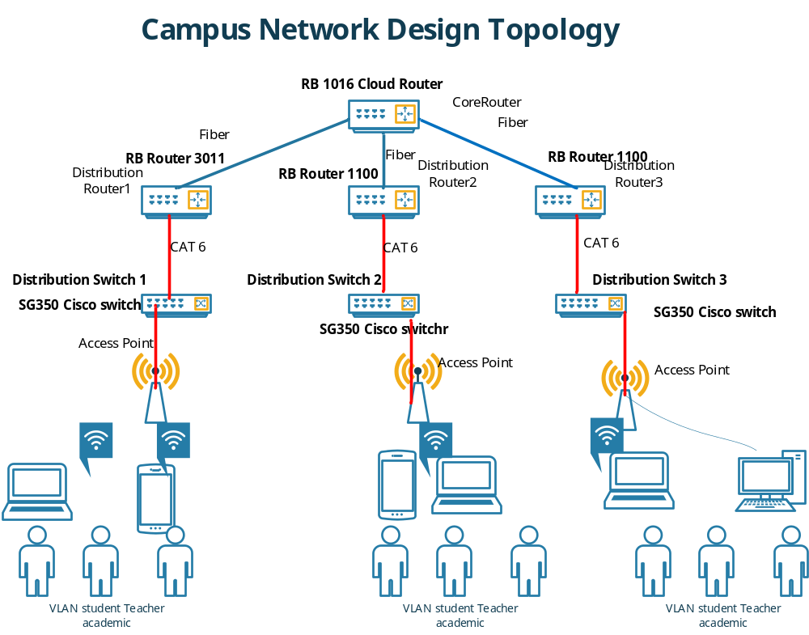

GE2/0.10 | 10.28.32.1 | 255.255.248.0
GE2/0.20 | 10.28.64.1 | 255.255.252.0
GE2/0.30 | 10.28.80.1 | 255.255.254.0

Student 2000

2048
2^11=2048 user

21 bit Network and 11 bit Host

Total ranges 10.28.32.0 /21---10.28.39.255

Subnet mask: 255.255.248.0

Teacher 1000
1024
2^10=1024

Net id 22 and Host 10 bit
10.28.64.0

Admin 500

10.28.32.0/21

10.28.0000

Core router Configuration

interface GigabitEthernet0/0
ip address 10.28.88.1 255.255.255.248
!
interface GigabitEthernet1/0
ip address 10.28.88.9 255.255.255.248
!
interface GigabitEthernet2/0
ip address 10.28.88.17 255.255.255.248
!
interface GigabitEthernet3/0
ip address 103.133.254.254 255.255.255.0
!

router ospf 1
router-id 1.2.3.0
log-adjacency-changes
redistribute bgp 65002 subnets
network 10.28.88.0 0.0.0.7 area 0
network 10.28.88.8 0.0.0.7 area 1
network 10.28.88.16 0.0.0.7 area 2
!
router bgp 65002
bgp log-neighbor-changes
no synchronization
neighbor 103.133.254.1 remote-as 65001
network 103.133.254.0 mask 255.255.255.0
redistribute ospf 1

Distribution Router 01
interface GigabitEthernet0/0
ip address 10.28.88.2 255.255.255.248

##VLAN Protocal

interface GigabitEthernet2/0.10
description vlan10_subinterface
encapsulation dot1Q 10
ip address 10.28.32.1 255.255.248.0
!
interface GigabitEthernet2/0.20
description vlan20_subinterface
encapsulation dot1Q 20
ip address 10.28.64.1 255.255.252.0
!
interface GigabitEthernet2/0.30
description vlan30_subinterface
encapsulation dot1Q 30
ip address 10.28.80.1 255.255.254.0
!

### DHCP Pool

!
ip dhcp excluded-address 10.28.32.1
ip dhcp excluded-address 10.28.39.255
ip dhcp excluded-address 10.28.64.1
ip dhcp excluded-address 10.28.67.255
ip dhcp excluded-address 10.28.80.1
ip dhcp excluded-address 10.28.81.255
!
ip dhcp pool vlan10
network 10.28.32.0 255.255.248.0
default-router 10.28.32.1
dns-server 103.133.254.2
ip dhcp pool vlan20
network 10.28.64.0 255.255.252.0
default-router 10.28.64.1
dns-server 103.133.254.2
ip dhcp pool vlan30
network 10.28.80.0 255.255.254.0
default-router 10.28.80.1
dns-server 103.133.254.2
!

OSPF Configuration

router ospf 1
router-id 1.1.1.1
log-adjacency-changes
network 10.28.88.0 0.0.0.7 area 0
network 10.28.32.0 0.0.7.255 area 0
network 10.28.64.0 0.0.3.255 area 0
network 10.28.80.0 0.0.1.255 area 0
!

Distribution 2
interface GigabitEthernet0/0
ip address 10.28.88.10 255.255.255.248
!
#VLAN
interface GigabitEthernet2/0.10
description vlan10_subinterface
encapsulation dot1Q 10
ip address 10.28.40.1 255.255.248.0
!
interface GigabitEthernet2/0.20
description vlan20_subinterface
encapsulation dot1Q 20
ip address 10.28.68.1 255.255.252.0
!
interface GigabitEthernet2/0.30
description vlan30_subinterface
encapsulation dot1Q 30
ip address 10.28.82.1 255.255.254.0
!
#DHCP
ip dhcp excluded-address 10.28.40.1
ip dhcp excluded-address 10.28.47.255
ip dhcp excluded-address 10.28.68.1
ip dhcp excluded-address 10.28.71.255
ip dhcp excluded-address 10.28.82.1
ip dhcp excluded-address 10.28.83.255
!
ip dhcp pool vlan10
network 10.28.40.0 255.255.248.0
default-router 10.28.40.1
dns-server 103.133.254.2
ip dhcp pool vlan20
network 10.28.68.0 255.255.252.0
default-router 10.28.68.1
dns-server 103.133.254.2
ip dhcp pool vlan30
network 10.28.82.0 255.255.254.0
default-router 10.28.82.1
dns-server 103.133.254.2
!

OSPF Configuration
router ospf 1
router-id 2.2.2.2
log-adjacency-changes
network 10.28.88.8 0.0.0.7 area 1
network 10.28.40.0 0.0.7.255 area 1
network 10.28.68.0 0.0.3.255 area 1
network 10.28.82.0 0.0.1.255 area 1
!
Distribution 2
interface GigabitEthernet0/0
ip address 10.28.88.18 255.255.255.248
!

#VLAN
interface GigabitEthernet2/0.10
description vlan10_subinterface
encapsulation dot1Q 10
ip address 10.28.48.1 255.255.248.0
!
interface GigabitEthernet2/0.20
description vlan20_subinterface
encapsulation dot1Q 20
ip address 10.28.72.1 255.255.252.0
!
interface GigabitEthernet2/0.30
description vlan30_subinterface
encapsulation dot1Q 30
ip address 10.28.84.1 255.255.254.0
!

###OSPF
router ospf 1
router-id 3.3.3.3
log-adjacency-changes
network 10.28.88.16 0.0.0.7 area 2
network 10.28.48.0 0.0.7.255 area 2
network 10.28.72.0 0.0.3.255 area 2
network 10.28.84.0 0.0.1.255 area 2
!

